PH 556: 2016 UNM Summer Institute in Community Based Participatory Research for Health (CBPR)
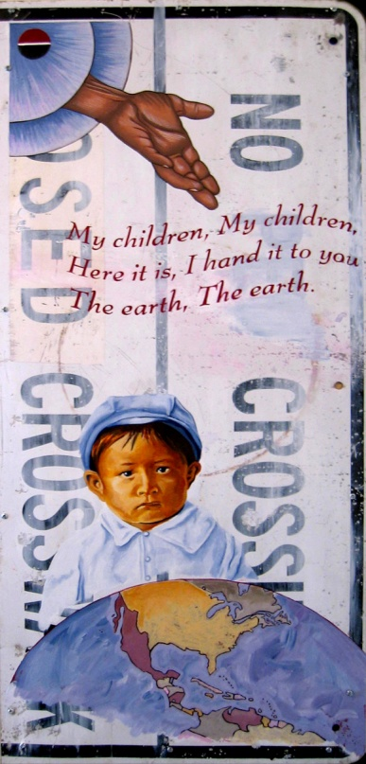 | Community Based Participatory Research Institute: Indigenous and Critical Methodologies  Public Health Program, School of Medicine, University of New Mexico  (2 or 3 graduate credits: Registration will open in March, 2016)  Contact Gayle at GarciaG@salud.unm.edu to put your name on the wait list.  Faculty:  Nina Wallerstein, DrPH NWallerstein@salud.unm.edu  Tassy Parker, PhD, RN, TaParker@salud.unm.edu  Lorenda Belone, PhD, MPH, LJoe@salud.unm.edu  Victoria Sánchez, DrPH visanchez@salud.unm.edu  Co-Sponsors: Center for Participatory Research; Institute for Indigenous Knowledge and Development; Robert Wood Johnson Center for Health Policy at UNM; HSC Offices of Diversity and Community Health; Community Engagement, CTSC; NM CARES Health Disparities Center, University New Mexico.  2016 Summer Dates (7th annual institute):  On-site: Tuesday, May 31st, 1-6 pm; Wednesday June 1st-Saturday June 4th, 8:30 - 5 pm  Off-site: TBD (within a few weeks): 3-hour Webinar for CBPR project presentations  Public Speaker: Thurs: 3:30-5 TBA  (Image Credit: “God Gives the World to Arapahoe Children” by America Meredith [http://www.ahalenia.com/america/]. Image reproduced by permission of the artist.)

Invitation to Participate:
For graduate students, post-doctoral fellows, faculty, community partners, academic-community teams, and others. This will be an intensive co-learning institute to explore how CBPR intersects with indigenous and critical methodologies, including the challenges for academics and community members to co-construct knowledge for improved community health. Students enrolled for 2 credits are expected to participate in readings, discussions, and journal-writing; for 3 credits, requirements include a CBPR paper based on one’s own research project. Enrollment is limited to 45 participants. For credit, UNM tuition (or tuition waivers) plus $40.00 fees. If not enrolled for credit: $700 for faculty or researchers; and $250 for community members or non-credit students.

Introduction to Institute:
Previous Participants:

I learned:
…“trust is built slowly through self-reflexivity, shared experience & action.”

…“how to get started and build partnerships.”

…the “importance of applying the CBPR principles when working with communities”

…“how interventions can be conducted in a CBPR setting.”

…that “The panel session on researcher identity was very intriguing and caused me to reflect on my roles with doing research & community engagement work.”

…that “I gained confidence to participate in CBPR.”

CBPR, and related-Participatory Action & Community-Engaged Research, is defined as a "collaborative approach that equitably involves all partners in research…with the aim of combining knowledge and action for social change to improve health and eliminate health disparities” (Kellogg Foundation). Not simply a set of research methods, CBPR or community-engaged research (CEnR) fundamentally changes the relationship between researchers and researched.
For this Institute, we use a broad definition of Indigenous, as the knowledge that is an “exercise in self-determination” (Doxtator, 2004), referring to values, beliefs, traditions, and environmental relationships that are deeply embedded within the economic, political and cultural-social contexts in which they have been developed (Ball & Simpkins, 2004; Briggs, 2005). Indigenous methodologies are “those approaches to research that privilege indigenous knowledges, voices, and experiences” (Smith 2005). Critical methodologies, grounded in Paulo Freire’s philosophy and cultural studies, are approaches to inquiry that are socially-constructed, emancipatory and empowering, and seek social justice for communities.

Structure of Institute:
The goal of this Institute is to weave together theory and practice of CBPR and CEnR with indigenous and critical methodologies through articles, presentations by community-academic partners, discussion, and self-reflection on our own research questions. Participants will gain an appreciation of CBPR advantages and challenges, as well as skills necessary for participating effectively in CBPR community-academic partnered research projects.

Readings:
- Minkler, M., and Wallerstein, N. (editors), Community Based Participatory Research for Health: From Process to Outcomes, 2nd edition, .S.F. Jossey-Bass, 2008; and 2) Reading Packet on LEARN at UNM.

